**FitFlex: Your Personal Fitness Companion**

**Ideation Phase**

**Empathize & Discover**

|  |  |
| --- | --- |
| Date | 31 January 2025 |
| Team ID | SWTID1741243418148473 |
| Project Name | FitFlex |
| Team Leader | FAMITHA S B |
| Team Member 1 | HARINI M |
| Team Member 2 | VARSHINI VR |
| Team Member 3 | JANANI M S |
| Team Member 4 | SATHVIKA E |
| Maximum Marks | 4 Marks |

**Empathy Map Canvas:**

An empathy map is a simple, easy-to-digest visual that captures knowledge about a user’s behaviours and attitudes.

It is a useful tool to helps teams better understand their users.

Creating an effective solution requires understanding the true problem and the person who is experiencing it. The exercise of creating the map helps participants consider things from the user’s perspective along with his or her goals and challenges.

**Example:**

Reference: <https://www.mural.co/templates/empathy-map-canvas>

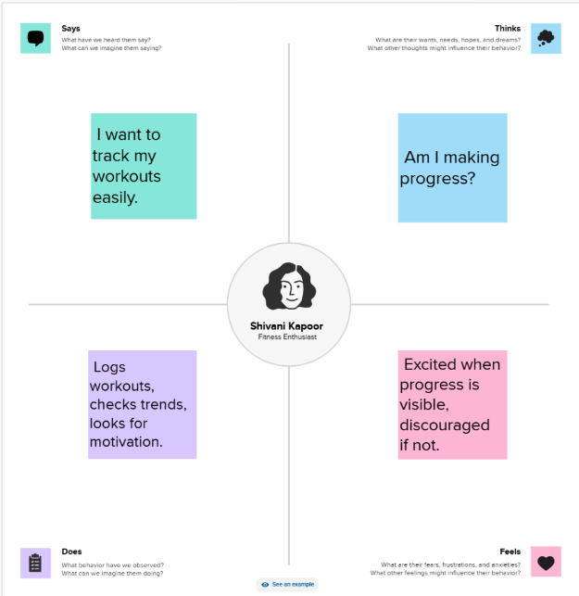

**FitFlex: Your Personal Fitness Companion**

**Ideation Phase**

**Define the Problem Statements**

|  |  |
| --- | --- |
| Date | 5 March 2025 |
| Team ID | SWTID1741243418148473 |
| Project Name | FitFlex |
| Team Leader | FAMITHA S B |
| Team Member 1 | HARINI M |
| Team Member 2 | VARSHINI VR |
| Team Member 3 | JANANI M S |
| Team Member 4 | SATHVIKA E |
| Maximum Marks | 2 Marks |

**Customer Problem Statement Template:**

Create a problem statement to understand your customer's point of view. The Customer Problem Statement template helps you focus on what matters to create experiences people will love.

A well-articulated customer problem statement allows you and your team to find the ideal solution for the challenges your customers face. Throughout the process, you’ll also be able to empathize with your customers, which helps you better understand how they perceive your product or service.

Reference: <https://miro.com/templates/customer-problem-statement/>

**Example:**

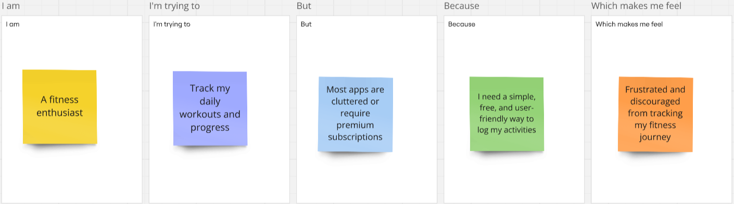

|  |  |  |  |  |  |
| --- | --- | --- | --- | --- | --- |
| Problem Statement (PS) | I am (Customer) | I’m trying to | But | Because | Which makes me feel |
| PS-1 | A fitness enthusiast | Track my daily workouts and progress | Most apps are cluttered or require premium subscriptions | I need a simple, free, and user-friendly way to log my activities | Frustrated and discouraged from tracking my fitness journey |
| PS-2 | A beginner in fitness | Start a workout routine and stay consistent | Existing fitness apps are too complicated or overwhelming | I need an easy-to-use interface with basic tracking features | Confused and unmotivated to continue |
| PS-3 | A busy professional | Monitor my steps and calories without manual input | Some fitness apps require too much manual data entry | I need automatic tracking with minimal effort | Annoyed and less likely to maintain consistency |
| PS-4 | A goal-oriented user | Set fitness goals and measure my progress | Most apps lack personalized goal tracking | I want a dashboard that visualizes my improvements over time | Uncertain about my progress and less motivated |

**FitFlex: Your Personal Fitness Companion**

**Ideation Phase**

**Brainstorm & Idea Prioritization**

|  |  |
| --- | --- |
| Date | 31 January 2025 |
| Team ID | SWTID1741243418148473 |
| Project Name | FitFlex |
| Team Leader | FAMITHA S B |
| Team Member 1 | HARINI M |
| Team Member 2 | VARSHINI VR |
| Team Member 3 | JANANI M S |
| Team Member 4 | SATHVIKA E |
| Maximum Marks | 4 Marks |

**Brainstorm & Idea Prioritization Template:**

Brainstorming provides a free and open environment that encourages everyone within a team to participate in the creative thinking process that leads to problem solving. Prioritizing volume over value, out-of-the-box ideas are welcome and built upon, and all participants are encouraged to collaborate, helping each other develop a rich amount of creative solutions.

Use this template in your own brainstorming sessions so your team can unleash their imagination and start shaping concepts even if you're not sitting in the same room.

Reference: <https://www.mural.co/templates/brainstorm-and-idea-prioritization>

**Step-1: Team Gathering, Collaboration and Select the Problem Statement**

**Step-2: Brainstorm, Idea Listing and Grouping**

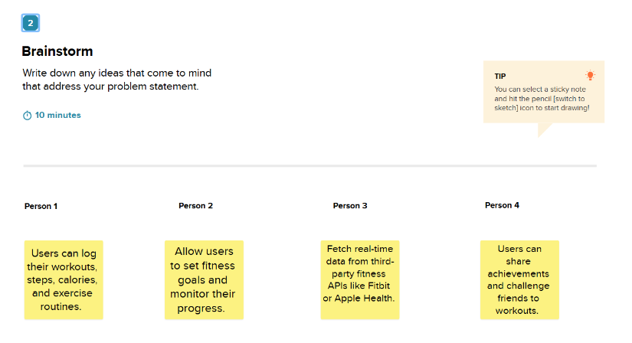

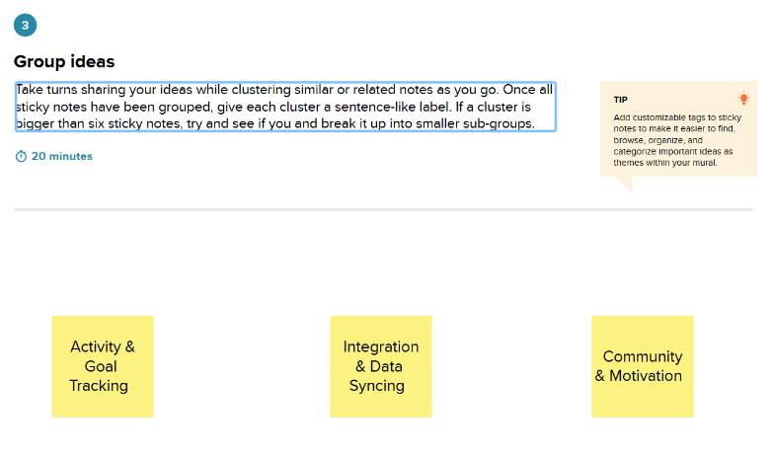

**Step-3: Idea Prioritization**

